

**MSc in Finance, MSc Quantitative Finance,**

**MSc in Financial data science**

FIN 41360

Portfolio and Risk Management

**Assignment 2: Risk Modelling**

Group 19

Word Count: 3969

3rd May 2024

Submitted by:

Finn Burke (23206021),

Shailesh Bhardwaj (23201526)

Bilal Rasheed (23202478)

Pranjal Kharbanda (23200194)

Ishika Trivedi (23200983)

Contents

1. Introduction 3

2. Literature review 4

3. Data 5

3.1 Portfolio with Equity Risk 5

3.2 Portfolio exposure to interest rate risk 5

3.3 Portfolio including the risk of equity and interest rates. 5

4. Portfolio construction 5

4.1 Portfolio sample period 6

5. Methodology 7

5.1 Parametric Estimations 7

5.1.1 Linear Distribution with Normality Assumption 7

5.1.2 Student's Linear Distribution 7

5.1.3 Expansion of Cornish-Fisher 7

5.2 Non parametric Estimates. 7

5.2.1 Historical Simulation (HS) 7

5.2.2 HS with Volatility Weighting 7

5.3 Alternative Estimate: Measurement of Spectral Risk 7

5.4 Back testing 8

5.5 Sensitivity analysis 8

6. Results 9

*6.1 Equity Portfolio* 9

*6.2 Bond Portfolio* 9

*6.3 Bond/Equity Portfolio* 9

*6.4 Back testing* 10

6.5 Sensitivity analysis 11

7. Takeaways 13

8.5 Further Factors to Consider 13

6. In conclusion 14

Appendix 15

Bibliography 23

# 1. Introduction

This study evaluates the risk profiles of three investment strategies to ensure financial institutions are well-capitalised against adverse market conditions. It involves analysing portfolios comprising S&P 500 stocks, typical financial institution bond holdings, and a mix of both. By employing both parametric and non-parametric methods, we assess VaR and ES, supplemented by spectral risk measures. Our findings are supported by a rolling window backtesting and a comprehensive sensitivity analysis, which identifies critical factors influencing risk estimations.

This research not only compares various risk estimates using academic literature and empirical data but also identifies the most reliable metrics for different types of risk exposures. We recommend normal linear VaR for equity exposure, historical VaR for interest rate exposure, and normal linear VaR for the combined portfolio. The paper is structured as follows: Section 2 provides a literature review; Section 3 outlines the data used; Section 4 describes the methodologies; Section 5 analyses the findings; and Section 6 concludes with our recommendations.

# 2. Literature review

Our risk analysis integrates insights from Hull (2012) and Dowd (2005), who propose distinct methodologies for Value at Risk (VaR) calculation. Hull suggests a 5th largest loss approach for a 5% 1-day VaR, while Dowd opts for the 6th largest loss, offering varying levels of conservatism. Addressing VaR interpolation challenges, a weighted average technique bridges exact loss quantiles, enhancing accuracy. Expected Shortfall (ES) estimation is refined using the Cornish-Fisher Expansion method by Acerbi and Tasche (2002), accounting for skewness and kurtosis. McNeil and Frey (2000) advocate ES over VaR, especially for heavy-tailed portfolios. Hull and White (1998) integrate volatility estimates via an EWMA model, supported by Alexander (2008) for improved risk prediction. Christoffersen and Pelletier (2004) endorse historical simulation for accuracy and efficiency, while Poon and Rockinger (2003) and Gourieroux et al. (2000) propose joint VaR and ES calculation methodologies, adapting to changing market volatilities.

Spectral risk measures by Cotter and Dowd (2006/2007) and Acerbi (2002) introduce exponential risk aversion functions for responsive risk measures. Lopez (1998) contributes the Lopez Test, facilitating comparative analysis and empirical validation of risk models, enhancing robustness.

Finally, Lopez (1998) contributes to the robustness of risk measurement models by introducing the Lopez Test. This method assesses different risk models based on the frequency of observed exceedances, thus facilitating a comparative analysis and ensuring the empirical validity of the models. This test illustrate the importance of rigorous empirical testing in the validation of risk assessment tools.

# 3. Data

Sample period: We gathered a dataset spanning 5 years, including 11 S&P 500 stocks and an interest rate ETF, using the Yahoo Finance database. The data covers the period from 1st January 2019 to 27th March 2024. The data library on Professor Kenneth French's website is used to get daily risk-free data. We did a back test starting from 10th March 2021 to 27th march 2024.

# 3.1 Portfolio with Equity Risk

The investigation in this study involves the collection of daily data on the biggest stock from each of the 11 S&P 500 GICS Sectors, as shown in Table 1. We use the modified closing price as the daily closing price for all portfolios and employ log returns to calculate the daily return. To allocate each stock, we calculate the weights of the tangency portfolio. We chose random weights for 1 million portfolio and selected the stocks with the with highest Sharpe ratio, we did this using python, and the code is attached with the file. To accurately represent an investment bank's real-world equities portfolio, we included a short-selling limitation. Additionally, we impose a constraint that ensures the total of the weights is equal to 100%.

### 3.2 Portfolio exposure to interest rate risk

For bond exposure, we examine instruments for example the Vanguard Total Bond Market ETF and iShares Core U.S. Aggregate Bond ETF, which serve as proxies for a standard financial institution's bond holdings. The chosen currency for this portfolio is USD, aligning with the equity portfolio. We use the same methodology to compute log returns from the modified closing prices, ensuring consistent risk measurement across asset classes.

### 3.3 Portfolio including the risk of equity and interest rates.

To mirror the risk exposure of a financial institution that opts for a moderate level of risk, we have adapted our portfolio strategy to the current low interest rate environment and anticipated rate cuts. Consequently, we have structured the combined portfolio with a 60% allocation to bonds and 40% to equities. This strategic allocation is specifically designed to mitigate the generally lower returns associated with such economic conditions, while leveraging the stability and income generation capabilities of bonds

# 4. Portfolio construction

Three investment portfolios have been prepared in accordance with the Board Committee's needs:  
• The equity portfolio is formed using the 11 sectors that are part of the S&P500 Index.  
• The bond portfolio is created by combining several types of US government and corporate bonds.   
• Combined Portfolio is created by combining a corporate bonds and diverse mix of stocks and bonds. The portfolios have been invested according to the risk-adjusted weights of their individual securities.

## 4.1 Portfolio sample period

The equity risk portfolio assets' daily data is obtained from Yahoo Finance for the time frame spanning from January 1, 2019, to 27th March 2024, in table 1 and 2including a five-year historical data period. Specific data is chosen for each of the 11 GICS sectors of the S&P 500 Index. The tangency portfolio is computed by using daily log returns and analysing the daily data. In our estimates, we include the daily adjusted closing price.

*Table 1: Constituents of Equity Portfolio*

|  |  |
| --- | --- |
| **Ticker** | **Weights** |
| XOM (Exxon Mobil) | 0.39 |
| META (Meta Platforms) | -0.02 |
| WMT (Walmart) | 0.00 |
| UL (Unilever) | -0.51 |
| DD (DuPont) | 0.69 |
| JPM (JPMorgan Chase) | 0.38 |
| AMT (American Tower) | 0.86 |
| ED (Consolidated Edison) | -0.12 |
| UNH (UnitedHealth) | 0.06 |
| AAPL (Apple) | 0.02 |
| DE (Deere & Company) | -0.75 |

*Table 2: Constituents of bond Portfolio*

|  |  |
| --- | --- |
| **Ticker** | **Weights** |
| BND (Vanguard Total Bond Market ETF) | 11.56% |
| AGG (iShares Core U.S. Aggregate Bond ETF) | 20.56% |
| GOVT (iShares U.S. Treasury Bond ETF) | 20.02% |
| LQD (iShares iBoxx $ Investment Grade Corporate Bond ETF) | 31.42% |
| SCHP (Schwab U.S. TIPS ETF) | 4.92% |
| VTEB (Vanguard Tax-Exempt Bond ETF) | 11.65% |

# 5. Methodology

## 5.1 Parametric Estimations

### 5.1.1 Linear Distribution with Normality Assumption

In this method, we assume a normal distribution of portfolio returns, characterized by their mean (μ) and standard deviation (). Utilizing the 99% confidence level (1-α), we calculate VaR and ES. This approach considers returns as independent, allowing for straightforward computation of risk metrics.

### 5.1.2 Student's Linear Distribution

Here, we employ Student's linear distribution, adjusting for the degrees of freedom (v). This method provides a robust estimation of VaR and ES, accommodating the potential deviation from normality observed in financial data. By incorporating the t-distribution, it offers a more flexible framework for risk assessment.

### 5.1.3 Expansion of Cornish-Fisher

Utilizing the Cornish-Fisher expansion, we enhance our risk estimation by considering the skewness and kurtosis of portfolio returns. This method provides a quadratic approximation, offering a refined perspective on risk. By accounting for non-normalities in return distributions, it enhances the accuracy of VaR calculations, thereby improving risk management strategies.

## 5.2 Non parametric Estimates.

### 5.2.1 Historical Simulation (HS)

The determination of net portfolio returns (P&L) in USD involves the multiplication of the percentage returns by the initial investment amount, which is USD 1 million. The P&L figures are thereafter arranged in descending order based on the biggest loss. In accordance with the literature study, we proceed to calculate the Dowd, Hull, and interpolation VaR/ES estimations.

### 5.2.2 HS with Volatility Weighting

The EWMA model in Equation 4 is estimated using the portfolio returns, a sample time i=550, and a decay factor κ=0.85, as stated in slides. The returns are modified according to Equation 3, and the Hull and Dowd Var estimates are calculated.

### 5.3 Alternative Estimate: Measurement of Spectral Risk

An alternative measure of spectrum risk is computed, which is not reliant on the parametric Value at Risk (VaR). As provided by Cotter and Dowd (2006), is adhered to in our analysis. To estimate the integral, we use the trapezoidal approach assuming a risk aversion value of 550. In order to determine the ideal value of 5000, a sensitivity analysis is conducted on the number of slices used. Additionally, the risk aversion coefficient is sensitised in order to get an ideal value of 550.

### 5.4 Back testing

The accuracy of the different risk estimations is verified by conducting out-of-sample forecast assessment using back testing techniques. The sample period used for this study consists of 550 trading days, with a significance level of 1%. The sample period is analysed using a rolling-window approach, with a risk horizon of 1 day. We assess the amount of exceedances by comparing the estimated Value at Risk (VaR) with the actual Profit and Loss (P&L). To determine whether to accept or reject the model, a one-tailed binomial distribution test is used on the exceedances. Next, we proceed to do Lopez testing.

### 5.5 Sensitivity analysis

Multiple sensitivity studies are conducted to assess the resilience of different estimates. Moreover, we modify the distribution within the equity-bond portfolio in order to comprehend the influence on Value at Risk (VaR).

# 6. Results

To determine the most suitable technique, we performed a one-tailed binomial test on four measures of Value at Risk (VaR): historical, volatility weighted, Normal, and t-student VaR. In addition to our testing, we conducted the Lopez Test. This facilitates the ability to make comparisons among the models that exhibit lower QPS scores, indicating their superior performance. The assessment of the accuracy of the Value at Risk (VaR) calculation and the monitoring of portfolio risk over time may be facilitated by using the likelihood of exceedance. If the likelihood of surpassing the anticipated value is greater than anticipated, it might suggest that the Value at Risk (VaR) estimation is insufficient.

## *6.1 Equity Portfolio*

The volatility-weighted Value at Risk (VaR) for equity portfolios records a QPS score of 0.040, indicating a robust performance. However, when comparing different VaR metrics, both Historical and t-Student VaR exhibit a QPS score of 0.035, suggesting they are nearly as effective. Notably, the Normal VaR achieves a much lower QPS score of 0.014, as seen in table 3 which highlights its superior predictive accuracy in estimating risk. For a risk manager, selecting Normal VaR as the preferred method for equity portfolios is crucial because it consistently underestimates risk less frequently than the other models, thus providing a more reliable and conservative risk management tool.

## *6.2 Bond Portfolio*

In the bond portfolio, the Normal VaR stands out with the lowest QPS score of 0.007, indicating exceptional accuracy in risk estimation, particularly useful in managing changing market volatilities. The t-Student VaR also performs well with a QPS of 0.057, showing its efficacy in capturing tail risks. However, the superior performance of the Normal VaR, despite concerns about its theoretical assumptions, suggests it may be more effective for real-time risk adjustments in bond portfolios. This makes it a preferred choice over the historically endorsed Historical VaR and the Volatility-Weighted VaR, which has a higher QPS of 2.505, indicating less predictive accuracy.

## *6.3 Bond/Equity Portfolio*

For the mixed Bond/Equity portfolio, the Normal VaR emerges as the most effective with a QPS of 0.014, making it highly suitable for capturing tail risks in a diversified portfolio. This compares favourably against the Historical and t-Student VaRs, which both have higher QPS scores of 0.035. The Normal VaR's superior performance underscores its capacity to handle complex risk profiles across both bonds and equities, offering a comprehensive and nuanced approach to risk assessment in mixed portfolios.

## *6.4 Back testing*

**Table 2**

**Statistical Evaluation of Exceedances using One-tailed Backtesting**

**Portfolios consisting of equity, bonds, and combined risk**

The graph illustrates the progression of both parametric and non-parametric risk indicators, which are used in the computation of VaR (Value at Risk) and ES (Expected Shortfall), via the use of statistical backtesting. A binomial one-tailed test is used to evaluate the accuracy of the anticipated VaR/ES in comparison to the real profit and loss statement. We assess whether the realised Profit and Loss surpassed the anticipated Value at Risk and record the outcomes as exceedance. The probability of exceeding a certain threshold is eliminated. The significance level is contrasted with the null hypothesis, which assumes that the risk model accurately calculates the Value at Risk (VaR) for the Equity Risk Portfolio**.**

**Table 3**

**The backtesting of excesses for Lopez**

The table presents a comprehensive analysis of the back testing conducted by Lopez, focusing on the efficacy of parametric and non-parametric risk metrics in computing VaR and ES. The QPS score of each model is determined by the quantity of identified instances that surpass a certain threshold. It enables a straightforward comparison of several models. The QPS is a numerical measure that ranges from 0 to 2. Models with lower QPS (Queries Per Second) scores, nearing 0, are regarded as having superior performance. Upon examining the Equity Risk Portfolio, it's clear that the Normal Linear Quadratic Portfolio Selection (QPS) is the most efficient, registering a QPS of 0.014, making it the preferred choice. Interestingly, both the Historical and t-Student models share a higher QPS of 0.035, indicating that they are equally effective, though less efficient than the Normal model.

## **6.5 Sensitivity analysis**

We see that the historical VaR estimate approach is significantly influenced by variations in λ and the distribution of investments between stocks and bonds. More precisely, when the parameter λ changes from 0.94 to 0.85, the Value at Risk (VaR) for a portfolio consisting of 60% equities and 40% bonds reduces dramatically from $25,468.53 to $16,468.15. Moreover, changes in the proportion of equities to bonds have a substantial effect on the Value at Risk (VaR), highlighting the portfolio's susceptibility to asset allocation preferences. For example, using a 60/40 allocation with a λ value of 0.94, the Dowd Value at Risk (VaR) is $25,468.53. When the allocation is modified to 70% equities and 30% other assets, the Dowd VaR rises to $50,200.51, indicating an elevated risk associated with a larger percentage of equity. On the other hand, a 50/50 allocation leads to a Dowd VaR of $37,433.25, which is lower than the 70/30 allocation but higher than the initial 60/40 allocation.

**Table 5,6 &7**

**Equity Portfolio, Bond and Combined portfolio sensitivity Analysis**

**The alterations in Lambda**

The lambda value has been determined. However, this value has received criticism based on study results suggesting that the decay factor should be in closer approximation to. An increased decay factor enhances the impact of previous data on volatility estimates. When evaluating risk, it is important to consider the impact of current volatility estimates on the sensitivity of risk evaluations. As a result, the lambda value is gradually reduced to see its effect on VaR. As lambda declines, VaR also falls, indicating a strong sensitivity to the decay factor lambda. Demonstrating the significance of matching risk tolerance with investors.

***Table 5 Sensitivity analysis equity***

**Table 6 Sensitivity analysis Bonds**

**Table 7 Sensitivity analysis Combined Portfolio 60/40**

**Table 8**

**Sensitivity Analysis of the Equity/Bond Portfolio for Different Weights**

The allocation of assets between equities and bonds may influence the value at risk (VaR). Due to the lower risk associated with bonds compared to stocks, increasing the allocation of bonds in the portfolio should result in a fall in the Value at Risk (VaR), and conversely, decreasing the bond weighting should lead to an increase in VaR. In order to verify this hypothesis, the weightings of the Equity/Bond portfolio are adjusted to assess their impact.

**Table 9**

**Conish Fisher's Bond Portfolio Sensitivity Analysis**

**Value at Risk (VaR) for Various Confidence Levels**

A reduction in the confidence level (α) is anticipated to lead to a fall in the Value at Risk (VaR). The significance thresholds used to assess the Cornish Fisher Value at Risk (VaR) are 1%, 2.5%, 5%, and 10%. The results demonstrate significant variability in the Value at Risk (VaR) throughout the selected confidence intervals. Alpha (α) VaR refers to the Value at Risk (VaR) measure that is calculated using the alpha level, denoted by the Greek letter alpha (α).

Alpha (α) VaR

**Table 10**

**Calculations of Spectral Risk Measures for Three Portfolios**

The findings were computed using a risk aversion coefficient of 500 and 5000 slices. It is evident that the observed values surpass the predetermined levels. The back testing of these data has not been conducted, hence the values in our recommendations are not taken into consideration.

|  |  |
| --- | --- |
| Spectral Risk Measure | |
| Equity | 58,200 |
| Bond | 11,723 |
| Equity/Bond | 39,339 |

# 7. Takeaways

As the risk manager, analysing the backtesting and sensitivity testing data is pivotal for the Board Risk Committee's risk measurement decisions. Backtesting results from Table 2 and Lopez backtesting from Table 4 offer insights into model performance. Notably, the Normal Linear model performs best for the Equity Risk Portfolio, evident from lower QPS scores. Sensitivity analysis in Tables 5 and 6 emphasizes parameter selection's significance. Specifically, adjusting lambda and portfolio weights supports the Normal Linear VaR model's choice. This adaptability enhances risk estimation accuracy by aligning with market conditions. Integrating backtesting and sensitivity analysis bolsters the recommendation for the Normal Linear VaR model, ensuring alignment with best practices and addressing recent market events.

## 8.5 Further Factors to Consider

Although these risk measurements are crucial for assessing investment choices, it is important to consider various other hazards from a macroeconomic standpoint. According to the latest projections from the IMF, global inflation is expected to decline to 5.8% in 2024 from a previous estimate of 6.8% in 2023. A reduction in inflation often leads to a declining nominal value at risk (VaR) due to a decline in the worth of financial assets. The reduction in possible losses for an investment portfolio would be a result of this.

It is anticipated to precipitate a modest economic downturn in America later this year. For example, Bond Market Liquidity Taskforce (BMLT) report by the International Capital Market Association (ICMA) has stated that liquidity in Bond market could be squeezed in the future and this is noteworthy when selecting the distribution of stocks and bonds in combined portfolio. Therefore, management must continually assess the liquidity profile of the bonds selected, prioritising those with higher liquidity to mitigate risks during unexpected volatility periods.As investors experience more uncertainty over the future ie., Russo Ukraine war and Israel Gaza war - there is a likelihood of market volatility. This, in turn, results in higher fluctuations in financial asset values and an increase in Value at Risk (VaR). Moreover, the reduction in liquidity within financial markets would lead to a subsequent rise in the Value at Risk (VaR).

# 6. In conclusion

Ultimately, we suggest using the Normal Linear Var/ES metric for both equity risk and combination risk portfolios due to its extensive use and comprehension among industry experts. Additionally, it facilitates the process of comparing various portfolios.

The importance of effective risk management in investment choices cannot be overstated, as it plays a pivotal role in the identification of possible hazards and the formulation of methods to minimise them. This practice serves to safeguard investments and ensure that investments are in line with the investor's risk tolerance and goals. The inclusion of this element is crucial for the effectiveness of any investment plan.

# Appendix

**Appendix 1: Equity Risk Portfolio:**

**Window Rolling-Window VaR Comparison**

**Appendix 2: Interest Rate Risk Portfolio:**

**Window Rolling-Window VaR Comparison**

**Appendix 3: Combined Risk Risk Portfolio:**

**Window Rolling-Window VaR Comparison**

**Appendix 4: Slice sensitivity**

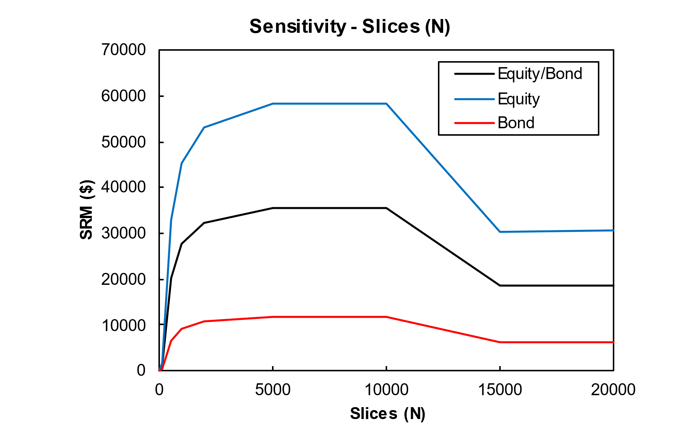

**Appendix 5 Risk aversion – sensitivity**

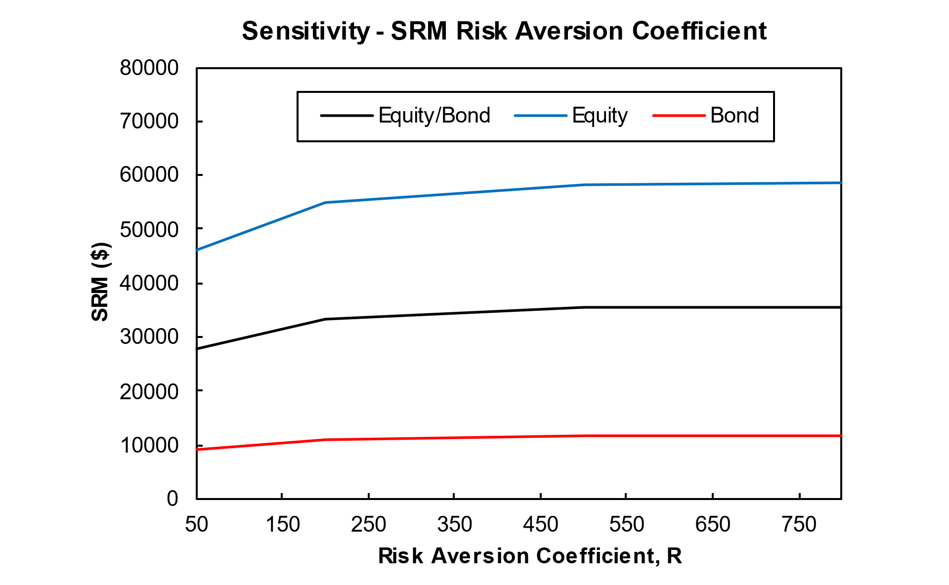

**Appendix 6 Value at risk and expected shortfall**

**Appendix 7 Back testing exceedances**

**Non Parametric**

**Parametric**

**Contribution**



# Bibliography

Cotter, J., & Dowd, K. (2006). Extreme spectral risk measures. *Journal of Banking & Finance*.

Carlo Acerbi, Claudio Nordio, and Carlo Sirtori. *Expected Shortfall as a Tool for Financial Risk Management*. Abazbank, Corso Monforte 34, 20122 Milano Italy, February 1, 2008.

French, K. Data Library (2024). *Current research returns*. Retrieved from [**https://mba.tuck.dartmouth.edu/pages/faculty/ken.french/data_library.html**](https://mba.tuck.dartmouth.edu/pages/faculty/ken.french/data_library.html)

Acerbi, C., Nordio, C., & Sirtori, C. (2008). *Expected Shortfall as a Tool for Financial Risk Management*. Abazbank, Corso Monforte 34, 20122 Milano Italy, February 1.

Amundi Investment Institute. (2024). *Capital market Assumptions 2024*. Retrieved from **<https://research-center.amundi.com/article/capital-market-assumptions-2024>**

International Monetary Fund. (2024). *World economic outlook update: Steady but slow: Resilience amid Divergence*. Retrieved [**https://www.imf.org/en/Publications/WEO/Issues/2024/04/16/world-economic-outlook-april-2024**](https://www.imf.org/en/Publications/WEO/Issues/2024/04/16/world-economic-outlook-april-2024)

Yahoo Finance. (2024). *Yahoo Finance*. Retrieved from [**https://finance.yahoo.com/**](https://finance.yahoo.com/)